Eve Reconsidered: A Gnostic View
Craig Chalquist, PhD, PhD
Chalquist.com
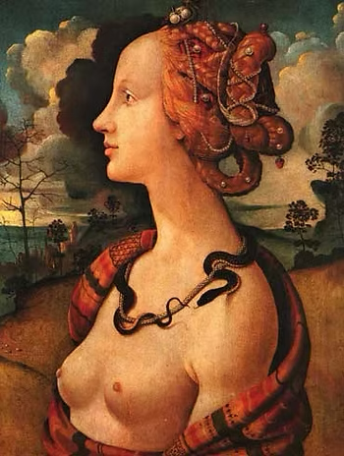
What makes us free is the gnosis of who we were of what we have become of where we were of wherein we have been cast of whereto we are hastening of what we are being freed of what birth really is of what rebirth really is.
–Excerpta de Theodoto
Even when archaic, creation myths carry enough lasting power to shape a worldview. A hefty percentage of Americans, for instance, believe in the standard story of Genesis. Many who do not believe in the Big Bang instead, a more modern story. Nevertheless, the official Adam and Eve have shaped how three religions and the cultures they invaded continue to depict women’s relations with men.
No one knows for sure exactly how the Gnostics came to be, although evidence suggests that they were a highly educated Jewish sect strongly influenced by Platonism. They shared a suspicion of orthodoxy, a love of wisdom, and a faith in finding one’s own way to the divine. They are not known to have oppressed or butchered anyone.
Until recently the church’s condemnation of them as misanthropic heretics stood until ancient Gnostic documents rediscovered since the late 1700s began to contradict this view. The find at Nag Hammadi, Egypt in 1945 provided a cornocupia of secret gospels to sort through, many without references to Christianity and others with obvious Christian overlays. They had been sequestered in a buried jar to protect them from self-appointed burners of sacred documentation.
That Christendom’s early leaders feared and hated women is no secret. This was particularly true of heresy fighters like Bishop Irenaeus of Lyons and Tertullian of Carthage, who referred to women as “the devil’s gateway” and asked, “Do you know that each of you are an Eve?” At that time many versions of Christianity relied on more than thirty sacred gospels; only later were these groups and texts condemned by an extremist wing bent on ascendancy. Among the “heresies” it most heavily condemned were the writings of the Gnostics. Little wonder. In documents written from the second to the fourth century, translations that drew on sources older than the Gospel of Mark, the Gnostics offer a very different version of what came to be accepted as the story of Eden.
Many of these early sources present Eve as created alongside Adam: obviously, since men emerge from women and not vice versa. But beyond that, Eve was often described as a spiritually superior being responsible for Adam’s awakening. In some sources she is an emanation of Sophia, a feminine manifestation of the divine. Slumber is a frequent Gnostic metaphor used to describe the common state of unreflective humanity; like the Buddha, the women and men of Gnosis believed humanity to be born into suffering and darkness made thick by the powers that be. The hatred of matter they occasionally displayed looks on closer inspection like a foresightful criticism of materialism–or, to use their term, hylicism. The purpose of gnosis, or knowledge through personally cultivated insight, was to awaken the mind and soul from dogmatism, materialism, and other forms of ignorance, penetrate the cycle of birth and rebirth, and regain contact with the sparks of God scattered throughout the world of matter. Such masters of awakening were known as “messengers of the Light.” The awakened became new messengers rather than worshipping or depending on their awakeners.
Most of the Gnostics did not distinguish between the roles of male and female messengers and regarded the expulsion from Eden as a testimonial to the birth of human consciousness. As a result, the early church banned their writings, and Gnosticism went literally underground as Roman and Egyptian gains in the equality of the sexes gave way before rigidly enforced patriarchal orthodoxy.
Of the dawn of consciousness Eve was both messenger and mother. This is from the text On the Origin of the World, a text so old it contains Aramaic word plays: When Eve saw Adam cast down, she pitied him, and she said, “Adam, live! Rise up upon the earth!” Immediately her word became a deed. For when Adam rose up, immediately he opened his eyes. When he saw her, he said, “You will be called ‘the mother of the living,’ because you are the one who gave me life.”
In this moving passage from the Apocryphon of John, Eve says of herself: …I spoke thus: “He who hears, let him arise from the deep sleep.” And then Adam wept and shed tears…He spoke, asking, “Who is it that calls my name, and whence has this hope come unto me, while I am in the chains of this prison?” And I spoke thus, “I am the foreknowledge of pure light; I am the thought of the undefiled spirit…Arise and remember…and beware of the deep sleep.”
She was right to issue her warning about that sleep: the sleep of unawareness, greed, cynicism, and power. She was silenced by it herself, the manuscripts wich echoed her voice suppressed by powerful clerics, with only a handful of codices left to be hidden safely away for more than a thousand years.
Imagine what the last two millennia might have been like had this image of the feminine been the prevalent one in the West.

